RFID Hall Pass – Final Project

Christopher Yang, Lautaro Stamati

Week 6 – 5/15/2025

Executive Summary:

We've completed the core code across four distinct versions, testing each extensively. Although the coding phase is done, we’ve identified an issue with the wiring that’s preventing successful reading and writing of strings to the RFID cards.

The wiring was initially kept consistent, but we've now realized that a misconnection may be the root of the communication problem. On the software side, we're embedding a string that includes the tag’s UID, location, and other relevant data.

In our multi-device setup, one unit is designated as the "master," routing all signals through its serial output, while the others act solely as detectors. With development otherwise finished, the final step is correcting the wiring to enable full communication between the cards and the system.

Schematic:

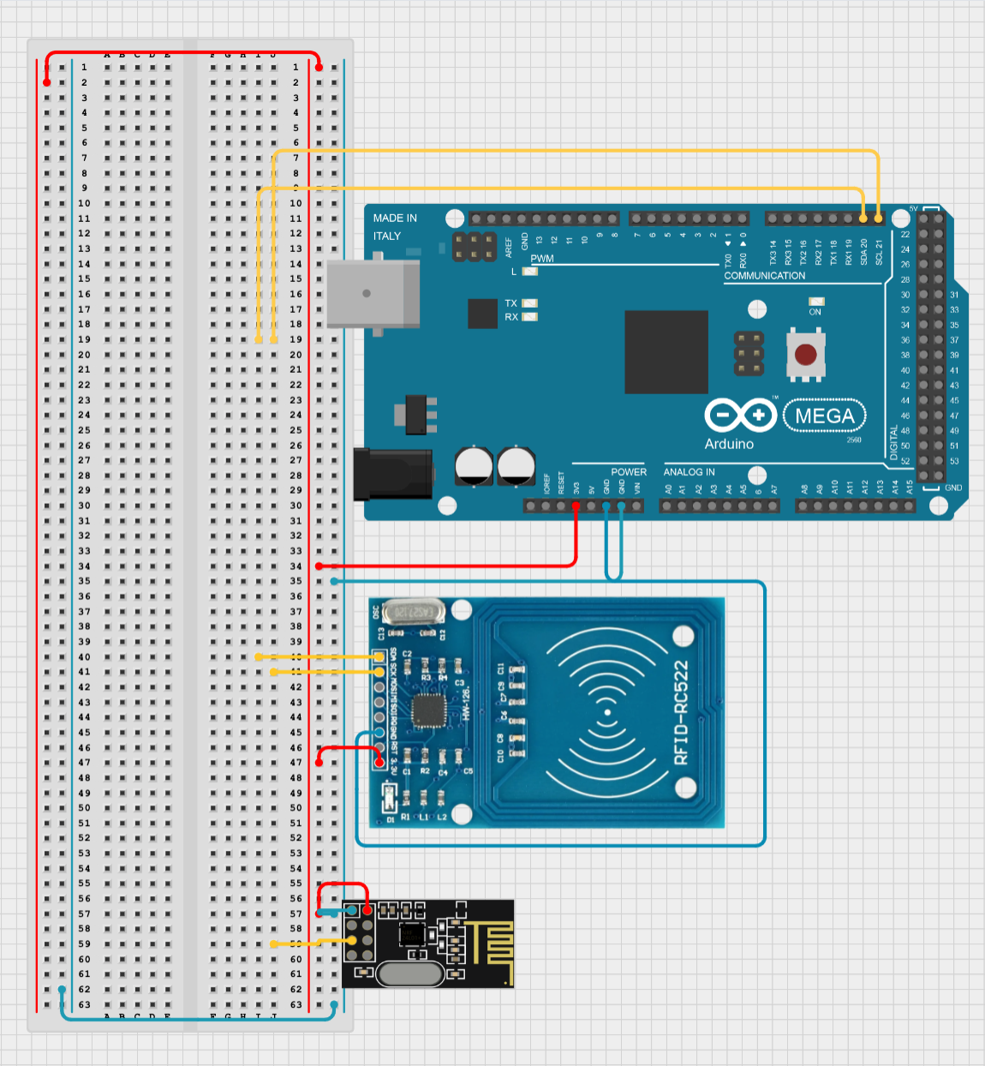

Gantt Chart & Planning:

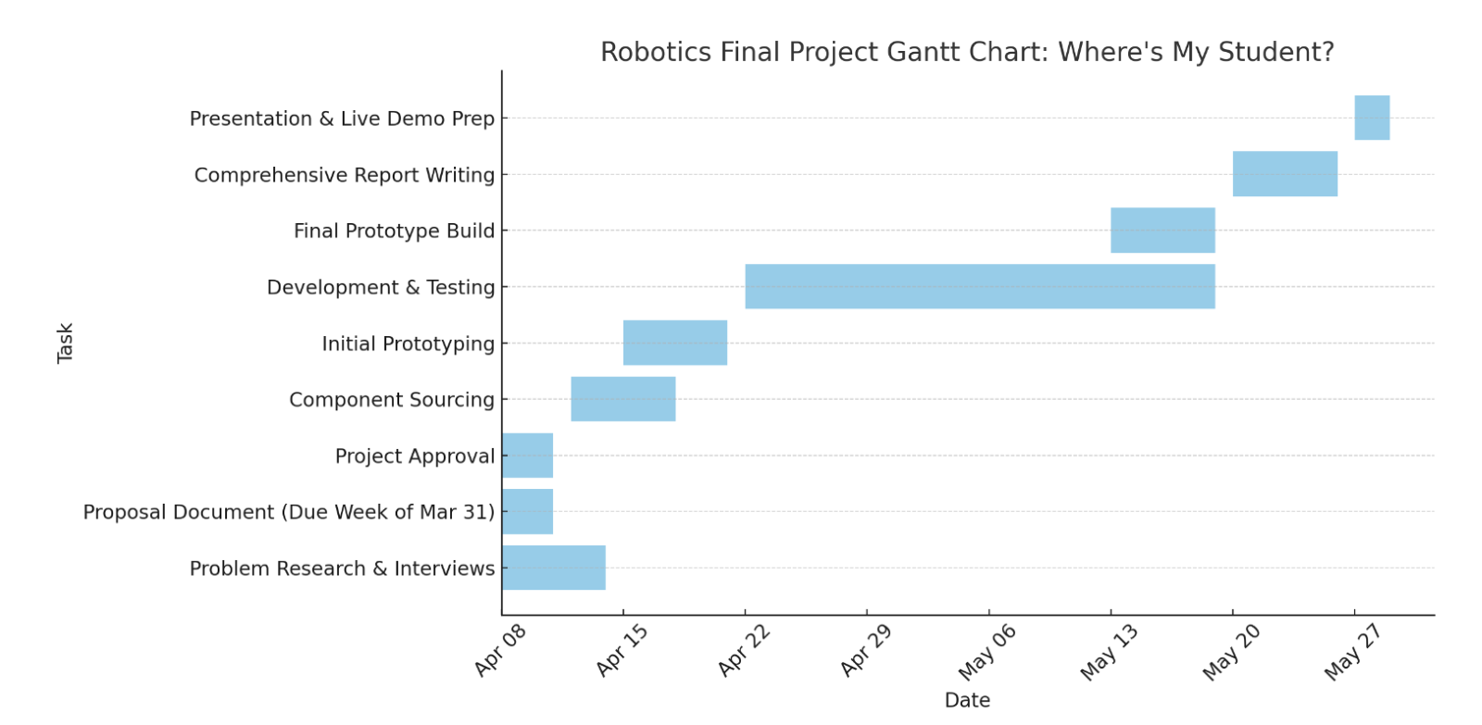

Next week, we’ll attempt to fix the wiring on the receiver. Once that is done the next step will be to design the box that surrounds our device.